Name: Zi Xi Hong

Recommend:50000-60000 ports

Exercise 3

Question 1:

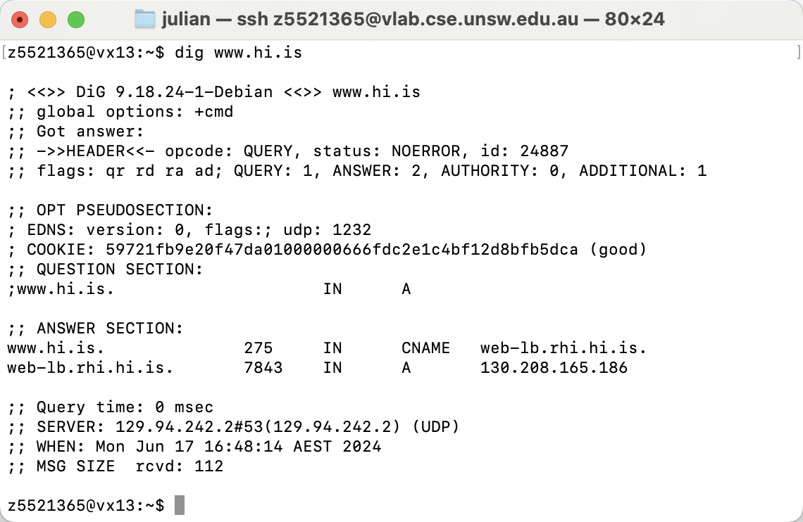

IP address is 130.208.165.186, A(type)

2.

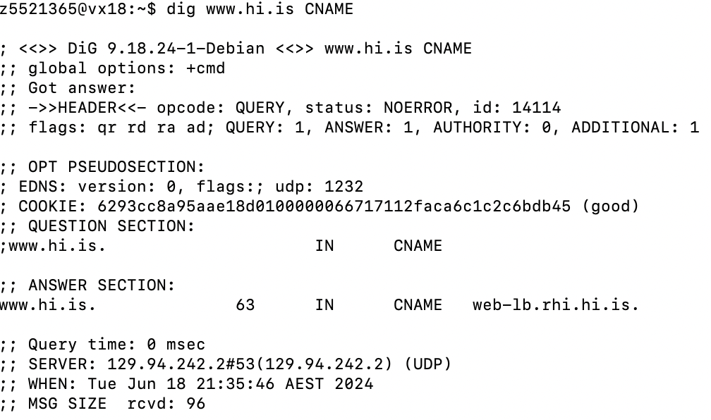

**Web-lb.rhi.hi.is**. is [www.hi.is](http://www.hi.is) ‘s canonical record name.

Canonical name is allowing website administrator to change the Ip address under sever without affect the user-face domain name. Canonical name is also very useful in distributing traffic among multiple servers.

3.

 **Cookie**: it generates Random DNS Cookies code which is use for preventing replay and verification attack

**EDNS:** The size limit of UDP packets is 1232 and the version is 0 which use extend DNS(EDNS0)

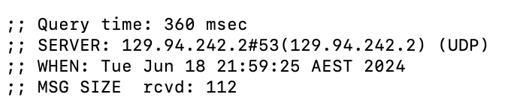

Query time: the time what it uses for querying.

DNS server IP address is 129.94.242.2, Port : 53

When: the time of query

MSG SIZE rcvd: The size of the received message is 112 bytes

4.

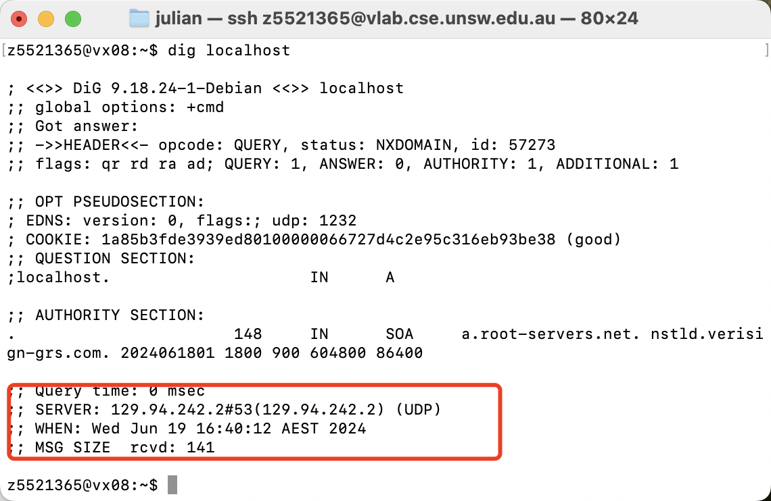

Local Name server IP address is 129.94.242.2

5.

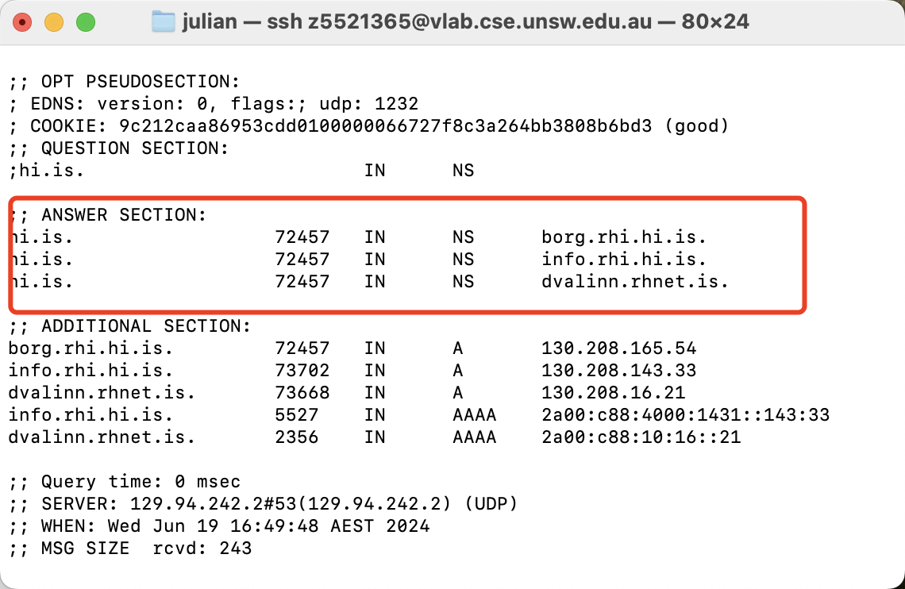

DNS query Type is NS , A

NS is use for catching the name of nameserver.

A is use for obtaining the IP address of nameserver.

6.

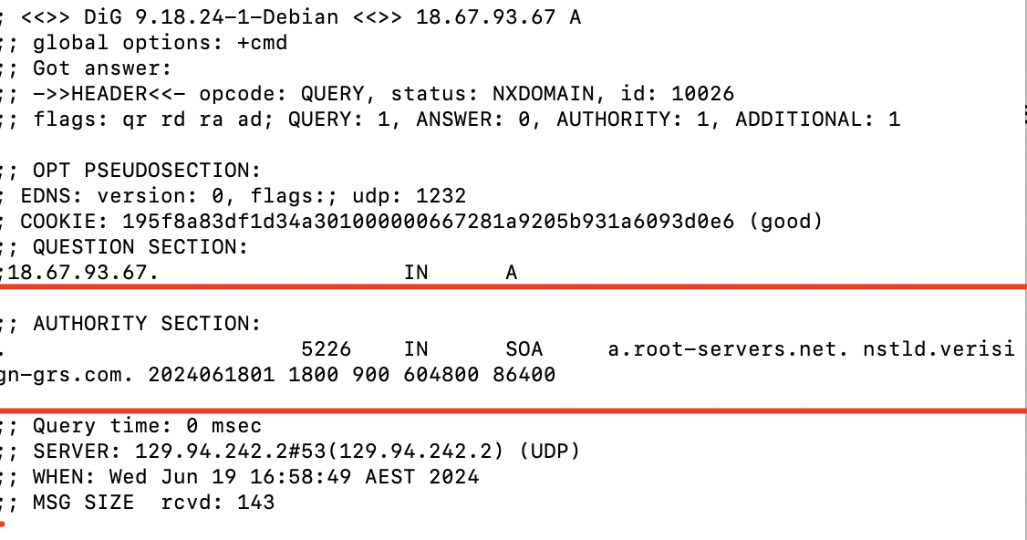

DNS name: a.root-servers.net. nstld.verisign-grs.com.

DNS query type : A

7.

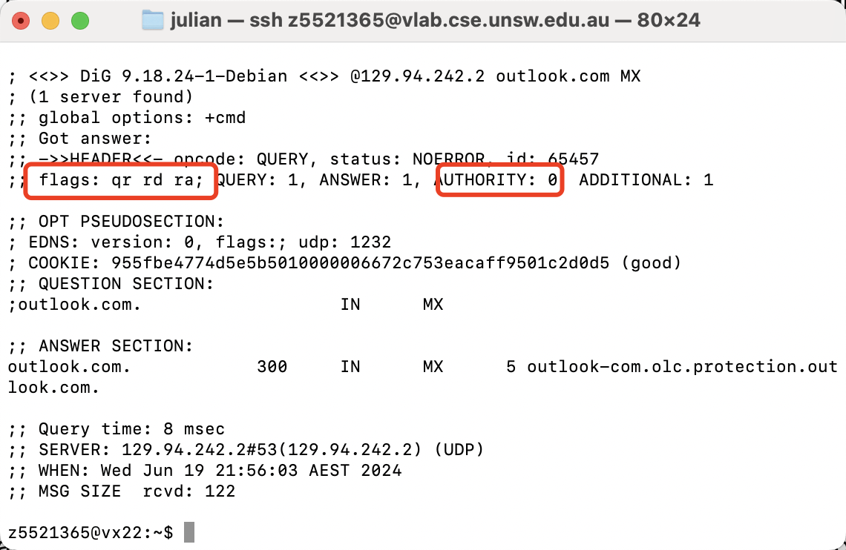

No , the flag in response message indicate that there is no “aa” which mean it’s not response from Authoritative name server.

8.

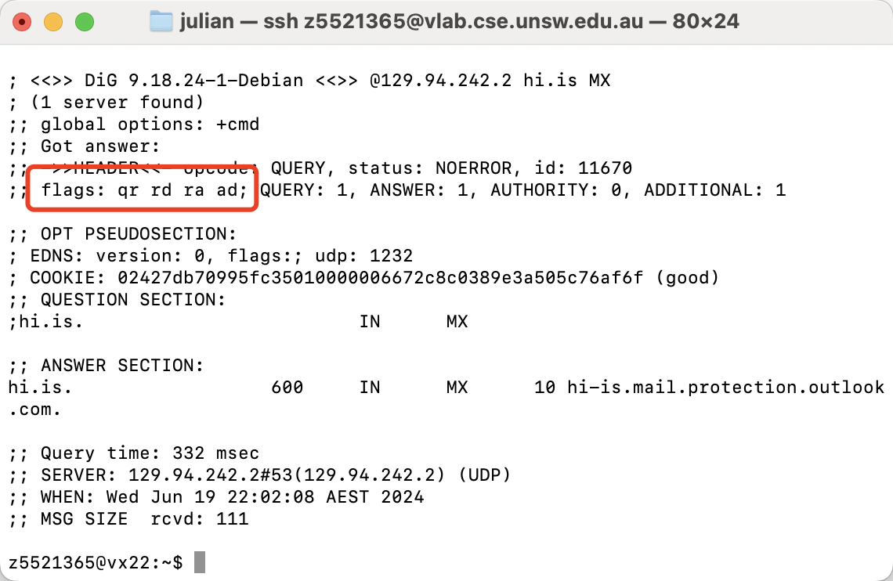

Result(ad) : Data is authenticated by DNSSEC , it guarantee the integrity and realistic of data.

9.

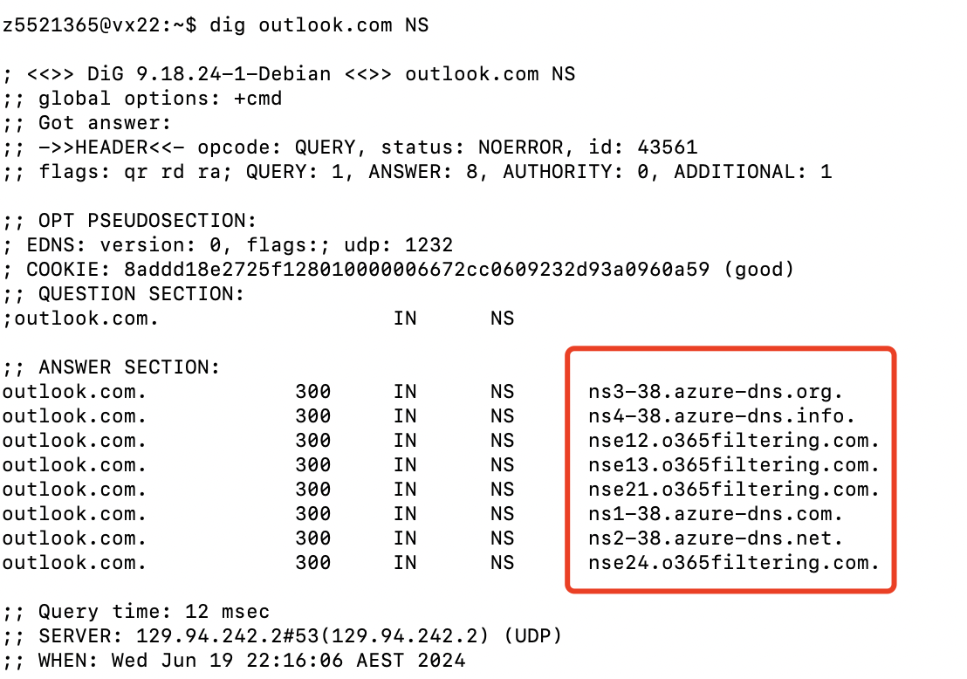

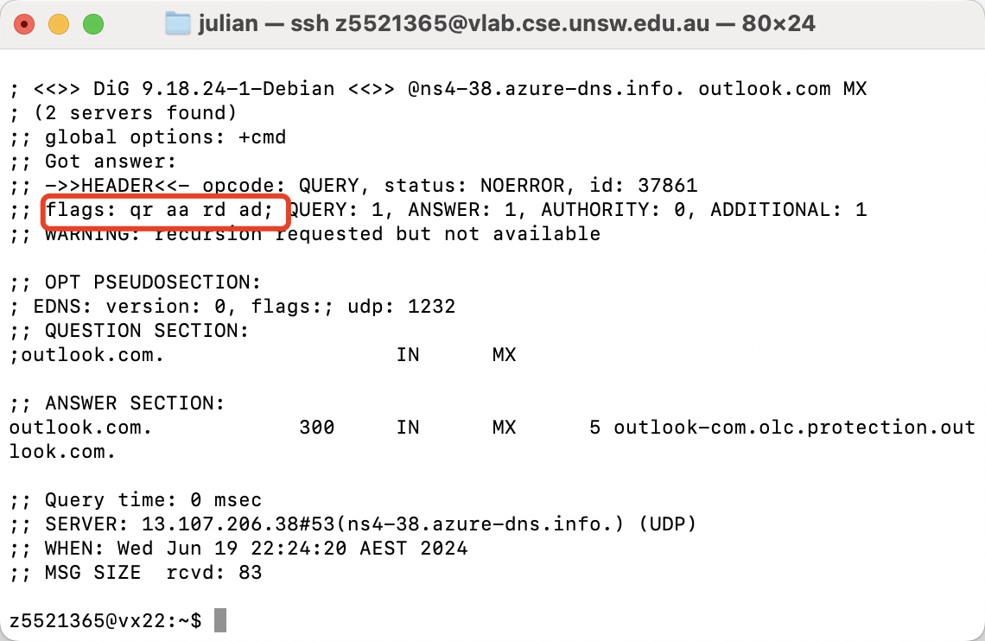

The type of query used to get the authoritative name server information is the NS record.

The query type used to obtain mail server information is MX record.

10.

Dig . NS

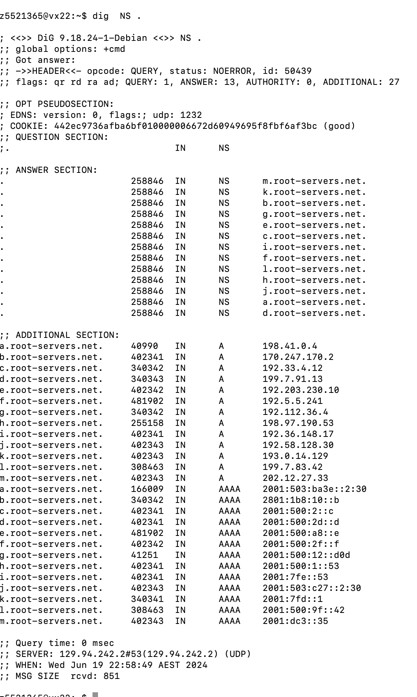

dig @m.root-servers.net. au. NS

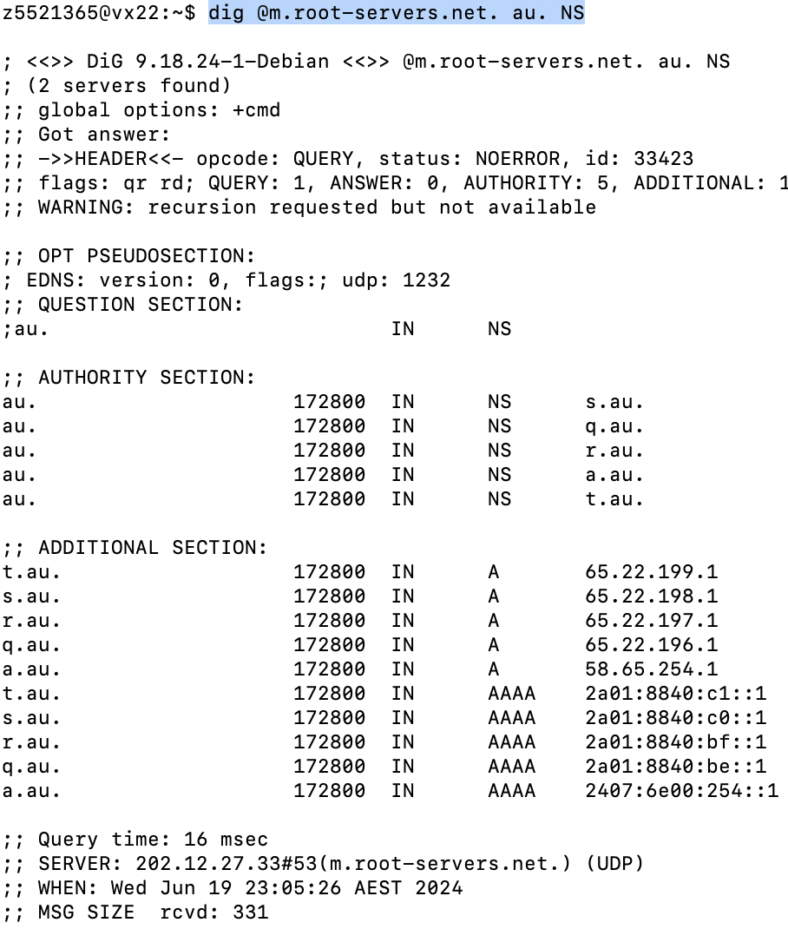

dig @s.au. edu.au. NS

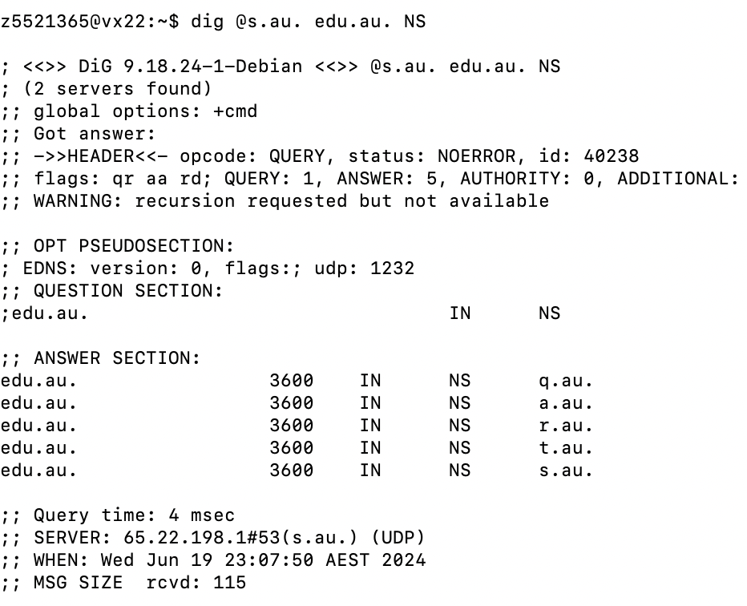

dig @s.au. unsw.edu.au. NS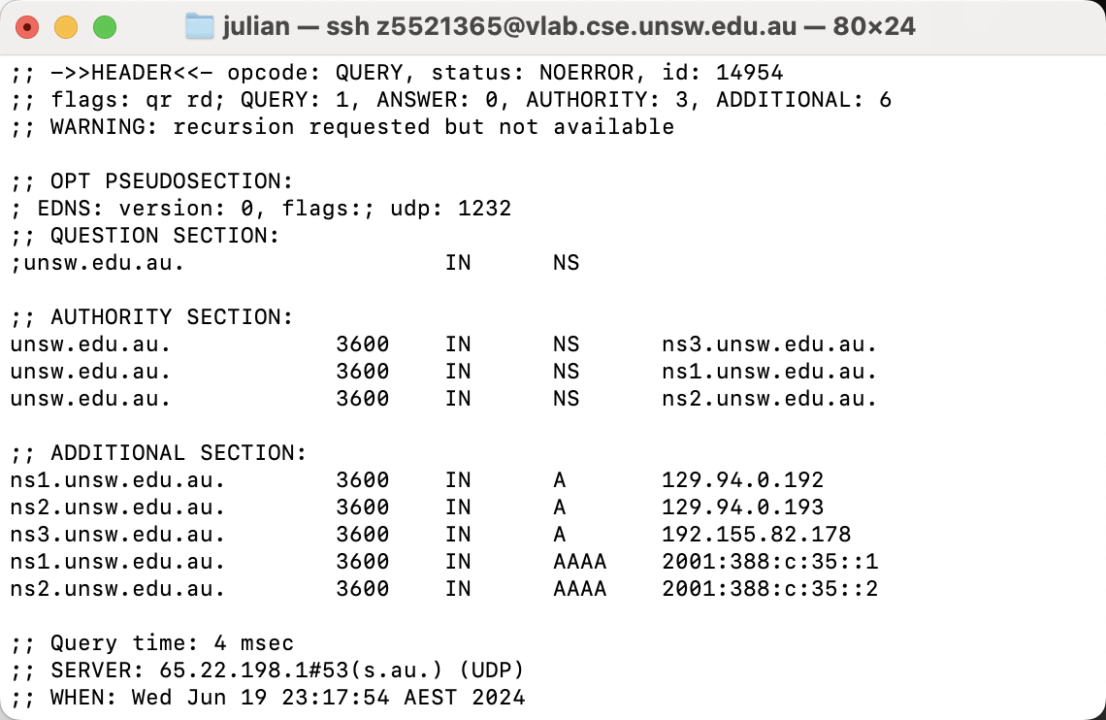

dig @ns3.unsw.edu.au. cse.unsw.edu.au. NS

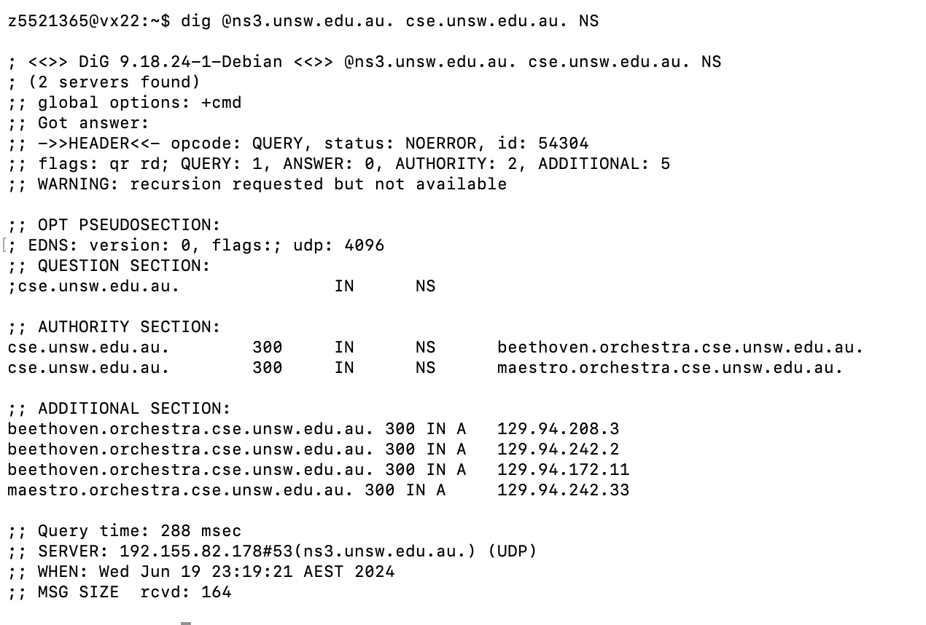

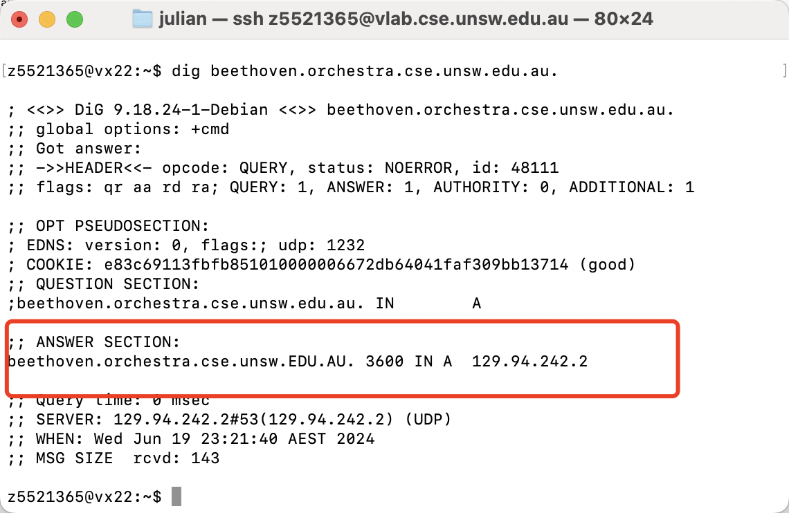

6 DNS servers

11.

Yes , It can

The machine may have many domains under hosting or have multiple NIC. It cause that it has different IP address.

Exercise 4 :

Just set the port: 49158

Index.html

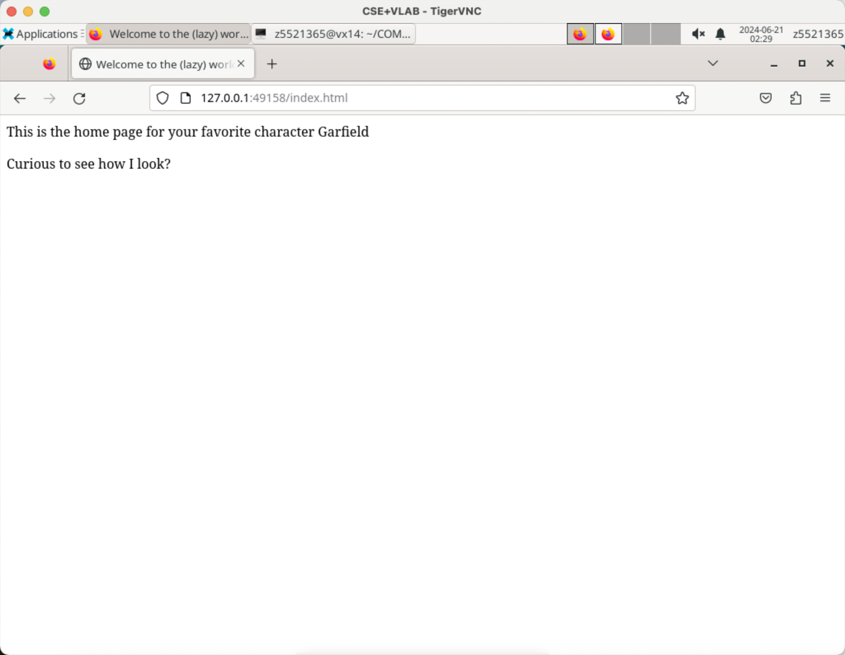

myimage.png



Bio.html

